Query Reference Documentation
To search your data, you must execute a query against an index.
An index is thought of as a collection of documents and a query is an action performed against an index in order to obtain specific data or information.
Before Executing Search
Before executing a search you must first make sure you are on the Discover tab of the user interface. If you are not please navigate to the discover section of the user interface and select the index pattern that you will like to perform your query against from this screen.
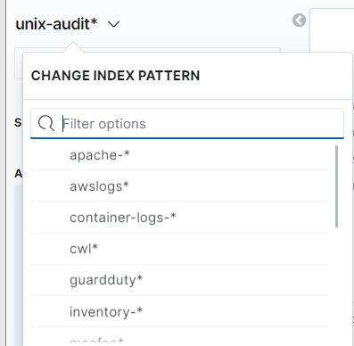

There are 13 index patterns currently and the data they supply
- Apache: httpd log data
- Awslogs: AWS log data
- Container-logs: docker container log data
- Cwl: Cloudwatch log data
- Guardduty: Guardduty log data
- Inventory: ec2 inventory documents
- Mcafee: contains Mcaffee log data documents
- Metrics: contains system metric data log documents
- Packetbeat: contains network traffic data log documents
- Unix-audit: contains auditd log data documents
- Unix-system: contains system level log data documents
- Win-log: Windows server data log documents
Elements of the search bar
The search bar is where you will input your query and it is where you will specify the time range to search in your data.
There are 4 components that make up the search bar.
- Saved Queries: You have the option to save your queries. When you would like to this is where you can perform the query saving action and this too is where you can view all saved query’s
- Search Field: This is where you type your search query
- Syntax Options: This is where you choose your language interpreter option. You can choose between KQL (Kibana Query Language) or Lucence. KQL is the selection by default
- Date selection: This is where you will specify the time range you would like to perform your query against

Types of Searches
When it comes to searching your data there are 3 core search types: free text search, field level search, and filter search.
Free text search:
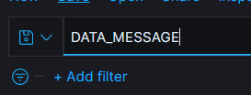
- Free texts search is the simplest search when used.
- It is performed against all index fields including the _source field.
- This also makes it the less performant as compared to the field level search.
- If there are no specific fields entered the search will search all fields. Free text searches are not case sensitive unless you use double quotes. Example: apache is up
Field level search:
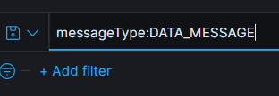
- This type of search allows you to search for a specific value mapped to a specific field.
- More performant and accurate than free text searching.
- Example: uptime:
- What is required is to add the name of the field as a prefix to the value you would like to search for.
- The results will limit the results of documents containing these responses but using field level searches also depend on the field type
- Wild card searches cannot be used for non-analyzed fields. Searches are case sensitive and have to be an exact match.
- There’s a lot and this is just on the aws index.
- By selecting the key, you can see the top values within each field, and you can create a filter that way.
- When you want to be more specific you can look at detail.eventname
- . clicking plus or minus not add You filter on assumed roles.
- It highlights what it finds within the logs and it filters it from the search.
- The data changes based on the configured timing.
- in the last 15 minutes this is what has happened.
- What is displayed is a rollup of the log but if you click to expand the document you can get a table of the log or you can get the data in json format of all of the specifics of that event.
- You can see all the fields. Not all fields will be populated unless it pertains to the data source.

Filter Search:
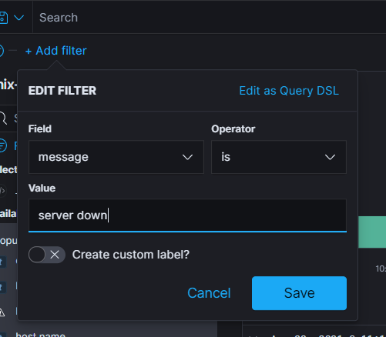
- This is a visual way in which you can interact with your data.
- You can create conditional filters based on the fields you have in your logs.
- The available conditionals are as follows: (is, is not, is one of, is not one of, exists, and does not exist).
- In the above example a filter is created against the message field to find values that are equal to “server down”.
Advanced Search Techniques

Booleans Queries - Allows you to perform queries with or, and , and not
Example: response:100 or response:300
Range Queries – response >= 200
Exist queries – query that matches all document values to a specified field.
Example: host.name:*
Wildcard Queries - search term that allows you to search for a term prefix to search for multiple fields or this can be used to search multiple values for a field
Example: agent.type:j*

For more information about searching please visit https://www.elastic.co/guide/en/kibana/master/kuery-query.html

